



Git

**Overview**

Git is a small yet very efficient version control tool. It helps both programmers and non-programmers keep track of the history of their project files by storing different versions of them.

1. [**What is Git?**](https://intellipaat.com/blog/tutorial/devops-tutorial/git-tutorial/#_What_is_git)
2. [**Why is Git used?**](https://intellipaat.com/blog/tutorial/devops-tutorial/git-tutorial/#_Why_is_git)
3. [**Git Life Cycle**](https://intellipaat.com/blog/tutorial/devops-tutorial/git-tutorial/#_Git_life)
4. [**Git Installation**](https://intellipaat.com/blog/tutorial/devops-tutorial/git-tutorial/#_Git_install)
5. [**Environment Setup**](https://intellipaat.com/blog/tutorial/devops-tutorial/git-tutorial/#_setup)
6. [**Common Git Commands: Local and Remote**](https://intellipaat.com/blog/tutorial/devops-tutorial/git-tutorial/#_command)
   1. [**Local Commands: init, status, add, commit, and clone**](https://intellipaat.com/blog/tutorial/devops-tutorial/git-tutorial/#_Local)
   2. [**Remote Commands: remote, push, and pull**](https://intellipaat.com/blog/tutorial/devops-tutorial/git-tutorial/#_Remote)
7. [**Branches in Git: checkout and branch**](https://intellipaat.com/blog/tutorial/devops-tutorial/git-tutorial/#_branch)
8. [**Merging in Git**](https://intellipaat.com/blog/tutorial/devops-tutorial/git-tutorial/#_marging)
9. [**Rebasing in Git**](https://intellipaat.com/blog/tutorial/devops-tutorial/git-tutorial/#_rebash)
10. [**Merging Conflicts and Rebasing Conflicts**](https://intellipaat.com/blog/tutorial/devops-tutorial/git-tutorial/#_merr)
    1. [**Solving the Conflicts**](https://intellipaat.com/blog/tutorial/devops-tutorial/git-tutorial/#_solve)
11. [**Git Workflows**](https://intellipaat.com/blog/tutorial/devops-tutorial/git-tutorial/#_workflow)

# What is Git?

Git helps developers keep track of the history of their code files by storing them in different versions on its own server repository, i.e., GitHub. Git has all the

functionality, performance, security, and flexibility that most of the development teams and individual developers need.

# Why Git Version Control?

Below are some of the facts that make Git so popular:

* Works offline: Git provides users very convenient options such as allowing them to work both online and offline. With other version control systems like SVN or CVS, users need to have access to the Internet to

connect to the central repository.

* Undoes mistakes: Git allows us to undo our commands in almost every situation. We get to correct the last commit for a minor change, and also we can revert a whole commit for unnecessary changes.
* Restores the deleted commits: This feature is very helpful while dealing with large projects when we try out some experimental changes.
* Provides security: Git provides protection against secret alteration of any file and helps maintain an authentic content history of the source file.
* Guarantees performance: Being a distributed version control system, it has an optimized performance due to its features like committing new

changes, branching, merging, comparing past versions of the source file, etc.

* Offers flexibility: Git supports different nonlinear development workflows, for both small and large projects.

# Git Life Cycle

* Local working directory: The first stage of a Git project life cycle is the

local working directory where our project resides, which may or may not be tracked.

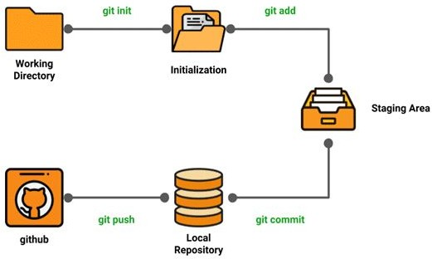

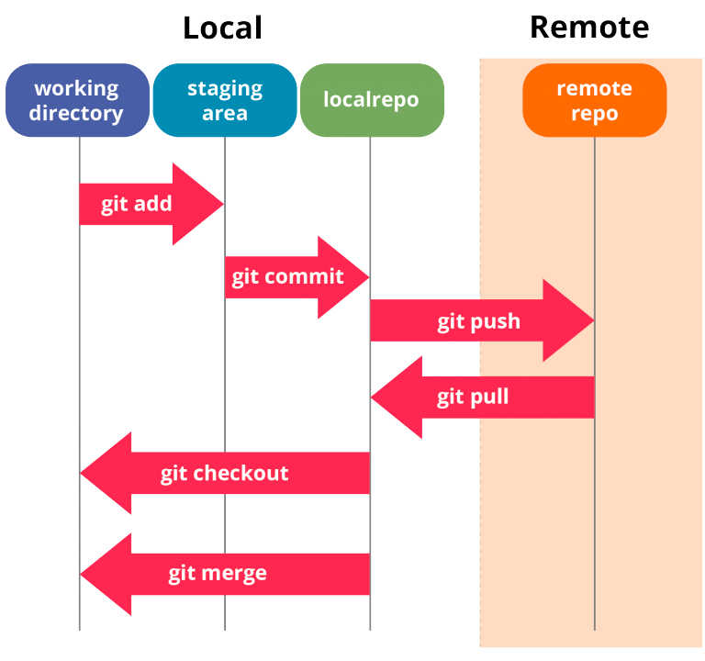

* Initialization: To initialize a repository, we give the command git init. With this command, we will make Git aware of the project file in our

repository.

* Staging area: Now that our source code files, data files, and configuration files are being tracked by Git, we will add the files that we want to

commit to the staging area by the git add command. This process can

also be called indexing. The index consists of files added to the staging area.

* Commit: Now, we will commit our files using the git commit -m ‘our message’ command.

We have successfully committed our files to the local repository. But how does it help in our projects? The answer is, when we need to collaborative projects, files may have to be shared with our team members.

This is when the next stage of the Git life cycle occurs, i.e., in GitHub, we publish our files from the local repository to the remote repository. And how do we do that? We do that by using the git push command.

* **git init** initializes a brand new Git repository and begins tracking an existing directory. It adds a hidden subfolder within the existing directory that houses the internal data structure required for version control.
* **git clone** creates a local copy of a project that already exists remotely. The clone includes all the project’s files, history, and branches.
* **git add** stages a change. Git tracks changes to a developer’s codebase, but it’s necessary to stage and take a snapshot of the changes to

include them in the project’s history. This command performs staging, the first part of that two-step process. Any changes that are staged will become a part of the next snapshot and a part of the project’s history. Staging and committing separately gives developers complete control over the history of their project without changing how they code and

work.

* **git commit** saves the snapshot to the project history and completes the change-tracking process. In short, a commit functions like taking a

photo. Anything that’s been staged with git add will become a part of the snapshot with git commit.

* **git status** shows the status of changes as untracked, modified, or staged.
* **git branch** shows the branches being worked on locally.
* **git merge** merges lines of development together. This command is typically used to combine changes made on two distinct branches. For example, a developer would merge when they want to combine changes from a feature branch into the master branch for deployment.
* **git pull** updates the local line of development with updates from its remote counterpart. Developers use this command if a teammate has made commits to a branch on a remote, and they would like to reflect those changes in their local environment.
* **git push** updates the remote repository with any commits made locally to a branch.

**Git Practical:-**

**Before getting into the repositories and all, we first need to configure user information for all the local repositories. Follow along :)**

**$ git config --global user.name "name"**

**$ git config --global user.email "**[**name@gmail.com**](mailto:name@gmail.com)**"**

**$ git config --global color.ui auto**

**user.name — Sets the name you want attached to your commit transactions**

**user.email — Sets the email you want attached to your commit transactions color.ui — Enables helpful colorization of command line output**

**Git Installation:**

**$ sudo apt-get install git**

**$ git --version**

* git clone “URL”
* cd Project-DevOps/
* touch git-demo.txt
* git add git-demo.txt
* git commit -m "first-commit"
* git push origin master

**Branch Creation:**

**Method-1**

* git branch Dev
* git checkout Dev
* git add git-demo1.txt
* git commit -m "new-branch"
* git push origin Dev

**Method-2**

* git checkout -b Prod
* git checkout Prod
* git add git-demo2.txt
* git commit -m "new-branch"
* git push origin Prod

**Git Merge:-**

**Git merge will combine multiple sequences of commits into one unified history. In the most frequent use cases, git merge is used to combine two branches. The following examples in this document will focus on this branch merging pattern. In these scenarios, git merge takes two commit pointers, usually the branch tips, and will find a common base commit between them. Once Git finds a common base commit it will create a new "merge commit" that combines the changes of each queued merge commit sequence.**

* git checkout -b branchname master
* git branch
* touch merge.txt
* git add merge.txt
* git commit -m "merging"
* git checkout master
* git merge branchname
* git push origin master

**Git Rename:-**

* git branch -m branchname

**Git Move:-**

* mkdir src
* touch learning.txt
* git add learning.txt
* git commit -m "moving"
* git mv learning.txt src/
* git push origin branchname

**Remove the Branch:-**

**// delete branch Locally**

* **git branch -d dev**

**// delete branch remotely**

* **git push origin --delete branchname**

**Git Tag:-**

* + git tag

// you can also search for tags that match a particular pattern

* + git tag -l "v1.8*"
  + git tag -a v1.4 -m "my version 1.4"
  + git tag
  + git show v1.4

// delete the tag

* + git tag -d v1.4
  + git tag

**Git Log:-**

* git log --all
* git log -3
* git log --author name
* git log --after 1
* git log --before 0.days.ago

// To view a summary of the changes made in each commit

* git log --stat

// To just get the bare minimum information in a single line per commit, use the –oneline option.

* git log --oneline

**Git Stash:-**

when you’ve been working on part of your project, things are in a messy state and you want to switch branches for a bit to work on something else. The problem is, you don’t want to do a commit of half-done work just so you can get back to this point later. The answer to this issue is the git stash command.

As already mentioned, Git's Stash is meant as a temporary storage. When you're ready to continue where you left off, you can restore the saved state easily:

Stashing takes the dirty state of your working directory — that is, your modified tracked files and staged changes — and saves it on a stack of unfinished changes that you can reapply at any time

* **git status**
* **git stash**
* **git stash list**
* **git stash apply**
* **git stash pop**